Consultants Specification Guide
SAFE System - Type B Dependency

Version: (1.4) 07/19

SAFE System

Within each Alarm Area*, in addition to the detection and alarm devices specified on the tender drawings a local SAFE system control device and associated interface shall be installed to allow the management of the Alarm Area* fire detection and alarm system and its interaction with the site Primary** fire detection system.

The SAFE control device shall be suitable for mounting on a single gang socket box, surface or flush and shall be available with the following options:
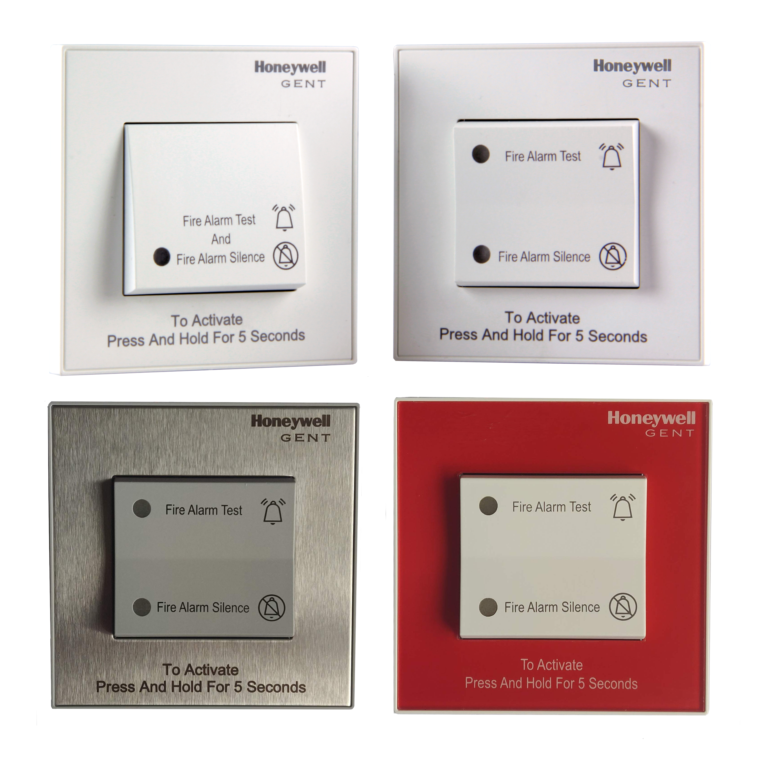
PART NUMBER | DESCRIPTION
SAFE-SS-D-KIT | SAFE 2 position, Stainless Steel, switch kit containing - SAFE Switch, 4 Channel Interface and wiring loom (Does not include interface enclosure)
SAFE-WHITE-S-KIT | SAFE 1 position, White, switch kit containing - SAFE Switch, 4 Channel Interface and wiring loom (Does not include interface enclosure)
SAFE-WHITE-D-KIT | SAFE 2 position, White, switch kit containing - SAFE Switch, 4 Channel Interface and wiring loom (Does not include interface enclosure)
SAFE-RED-D-KIT | SAFE 2 position, Red, switch kit containing - SAFE Switch, 4 Channel Interface and wiring loom (Does not include interface enclosure)
34701 | T breaker device

A 4 channel interface unit shall be installed in the vicinity the SAFE control Switch that will be connected to the fire detection loop. The interface unit will manage and control the interaction between Alarm Area* and the Primary** fire detection and alarm system in the development. The interface unit should be separate from the SAFE control switch to enable the option to have accessibility either in the Primary** area of the property or within the defined Alarm Area*.

Each loop connected to the fire alarm control and indicating panel shall be capable of controlling up to a maximum of 32 Alarm Areas* less any other control areas connected to the loop such as landlords controls (Sounders and interfaces). The loop wiring in an Alarm Area* can be installed in the form of a complete loop or a spur off the main loop using a ‘T’ Breaker device.

The SAFE system control switch shall be connected to the Alarm Area* interface unit using 2 x 4core 1.5mm² PVC /PVC cables.

The fire detection and alarm system within the Alarm Areas* shall be capable of the following:

- On receipt of an unconfirmed alarm from an automatic detection device within an Alarm Area*, the alarm sounders only in that Alarm Area* shall be activated. If the initial fire condition is confirmed by a second signal, from another device sensor, call point (in the same Alarm Area*) or a different sensor element within a multi-criteria detector, the fire system shall proceed to the relevant building evacuation strategy.

- If the heat element is activated in the multi criteria detector at any stage during a delay period, this should override the delay period and activate the systems full cause and effect.

- If a confirmation signal is not received in the Alarm Area* (from another device sensor or call point), or a different sensing element (heat for example) within a multi-criteria detector (in the same Alarm Area*) the system shall reset automatically without any need for manual intervention.

- It shall be possible to silence the local alarm condition for a period, configurable based on the risk assessment of the dwelling (between 0-4mins), to allow the resident to investigate the local alarm in the Alarm Area*. If the detection device activated is still detecting a fire after the period of delay, the local alarm in the Alarm Area* shall be re-activated and the relevant building evacuation strategy shall be activated. Additionally, during the silence period, a confirmed fire by a second signal (from another device sensor or call point) or a different sensing element (heat for example) within a multi-criteria detector, within in the same Alarm Area*, the local alarm in the Alarm Area* shall be re-activated and activate the systems full cause and effect.

- Where the local alarm condition is silenced and the period of delay is activated a warning signal shall be given by the fire detection and alarm devices that the fire detection system will re-activate in the alarm area 30 seconds prior to the alarm signal reactivating.
- It shall be possible to programme a ‘Wardens’ (office, control room, concierge etc..) area sounder which will sound an alarm in the event of any *Alarm Area in the development activating a first stage alarm in order to draw the attention to staff that may be present on site. The sounder will silence automatically should the Alarm Area device be automatically reset or shall react in accordance with the site cause and effect should there be a genuine fire after the period of delay.

The detection and alarm devices within the Alarm Area* shall be capable of providing an alarm signal in the form of a ‘Voice Message’ from the audible alarm devices installed. The audible warning devices within the Alarm Area* shall firstly draw the occupant’s attention to an incident by playing an attention-grabbing tone with a signal of 500hz to 1000hz, the devices shall then be capable of transmitting the following messages:

- Smoke detected in Alarm Area - Male voice - “Attention please, attention please. Smoke has been detected in your area, please investigate and clear any smoke, if safe to do so, please press your SAFE delay switch” The message is preceded by a warning tone.

- Where the building policy is stay put - Male voice – “Attention please, attention please. An incident has occurred in the building, please stay put and await further instruction.” The message is preceded by a warning tone.

- Building evacuation alarm - Male voice - “Attention please, attention please. An incident has occurred in the building, please leave the building immediately by the nearest safe exit, do not use the lifts.” The message is preceded by a warning tone.

- All clear Message - Male voice - “Attention please, attention please. The incident has been resolved and there is no need to evacuate” The message is preceded by a warning tone.

- Test message – Male voice – ‘Attention please, attention please this is a test of the fire alarm system no action is required’

The SAFE control switch shall under normal conditions is to be used to test the alarm devices within the Alarm Areas* only, by pressing the switch. The Alarm Area devices shall operate a fire tone within the Alarm Areas* for a period 2 seconds and then silence automatically. The operation of the test mode shall not operate any other alarm devices within the building. All tests of the alarm systems with the Alarm Areas* shall be recorded in the fire alarm control panel event log.

The SAFE control switch, under non-fire conditions shall allow, the local devices to be disabled in the Alarm Areas* for a predefined period (configurable based on risk assessment) by the Occupant pressing the SAFE Control switch. After the period of time has elapsed the devices in the Alarm Areas* shall be automatically re-enabled.

The fire alarm system should be able to report the test procedures carried out within the protected building and highlight all Alarm Areas and their compliance to EN54-6 testing regimes (monthly tests). It should highlight all completed tests as well as Alarm Areas that have failed to complete the monthly test. Furthermore, it should be able to report all the incidents, by Alarm Area, of the activation of the alarm silencing function on the SAFE system control button.

*Alarm Area – Dwelling, Apartment, Floor, Zone
**Primary – Main fire detection system outside of the Alarm Area (example landlord’s area in an apartment block)

System Architecture, Wired S-Quad

The specified solution should be able to be wired in the form of a loop or a spur from the main loop using a T breaker device, additionally where specified the solution should be capable of being interfaced with third party domestic detectors to provide safety on everyday homes based on compatibility. T Breaker can also be used to reduce cabling.

