Honeywell Posi 3 USB Licensed Software Request Form
To: | Click here to enter Honeywell representative.
From: | Click here to enter your name and contact information.
Date: | Click here to select a date.
License For: | Click here to enter Licensee (company) name.
Connection Type: | USB – Posi 3 USB
Purchase Type: | New - A training certificate is required for each SCBA manufacturer selected.  Lost/Replacement Disk - A Posi3 USB test results page is required for replacement. Subject to a replacement fee.  Address Change - A test results page showing old license information is required for each SCBA manufacturer version selected.
Test Results Page(s): | Yes No
Manufacturer Software by SCBA Type (please check all that apply)
Standard/Generic p/n 54-58-10 | Imperial
Standard/Generic p/n 54-58-03 |  | Metric
Honeywell (Survivair) p/n 54-58-01 | Imperial
Honeywell (Fenzy) p/n 54-58-04 |  | Metric
Avon / ISI p/n 54-58-06 | Imperial
Draeger p/n 54-58-02 | Imperial
Interspiro p/n 54-58-05 | Imperial
Interspiro via FTP d/l p/n 54-58-15 | Imperial
MSA p/n 54-58-07 | Imperial

*License Information: (three lines of code / MAXIMUM of 30 characters per line)
* Información sobre la licencia: (tres líneas de código / 30 caracteres por línea)
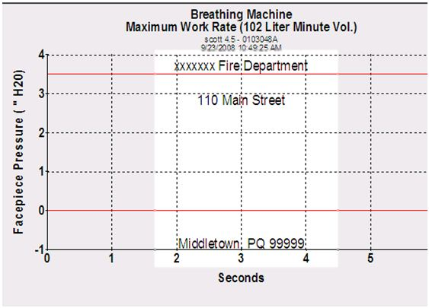
Example / Ejemplo:
xxxxxxx Fire Dept
110 Main Street
Middletown, CT 99999

Line 1 | Click here to enter 30 characters (spaces).
Line 2 | Click here to enter 30 characters (spaces).
Line 3 | Click here to enter 30 characters (spaces).
Signature:

